EXP 9 K MANOJ KIRAAN
240701305

Create Blueprint Using Zoho Creator

Aim
To design and implement a blueprint in Zoho Creator to manage the investigation case lifecycle in the EviTrace application.

Procedure
- Open the EviTrace application in Zoho Creator.
- Navigate to Workflow → Blueprints.
- Create a blueprint named Investigation_Case_Lifecycle for the Investigation Cases form.
- Define the stages as Case Opened, Evidence Collection, Forensic Examination, and Case Closed.
- Configure transitions such as Start Evidence Collection, Begin Forensic Examination, and Close Investigation.
- Set the required transition conditions and actions to control movement between stages.
- Enable the blueprint and test the transitions using investigation case records.

Output

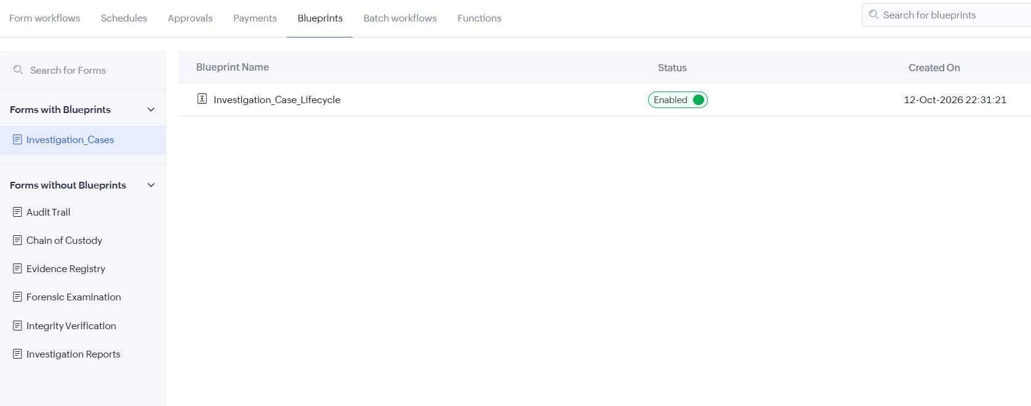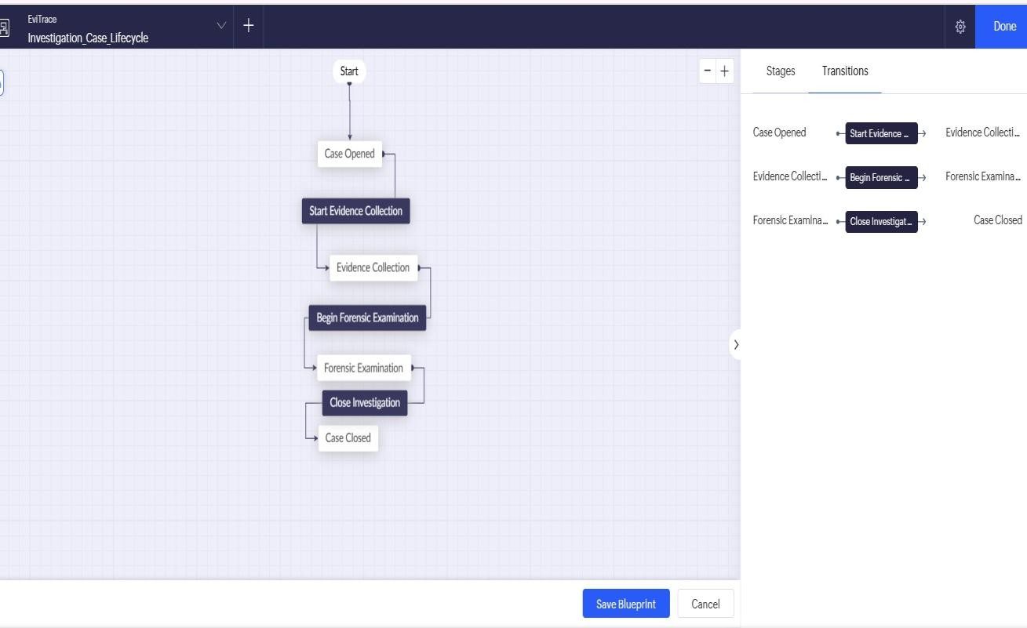

Result
The Investigation_Case_Lifecycle blueprint was implemented to manage investigation cases through defined stages and transitions.

